STEPS FOR A

SUCCESSFUL

CAMPAIGN.

YOUR GUIDE TO COORDINATING
A UNITED WAY
WORKFORCE CAMPAIGN.

WELCOME TO THE
UNITED WAY CAMPAIGN!

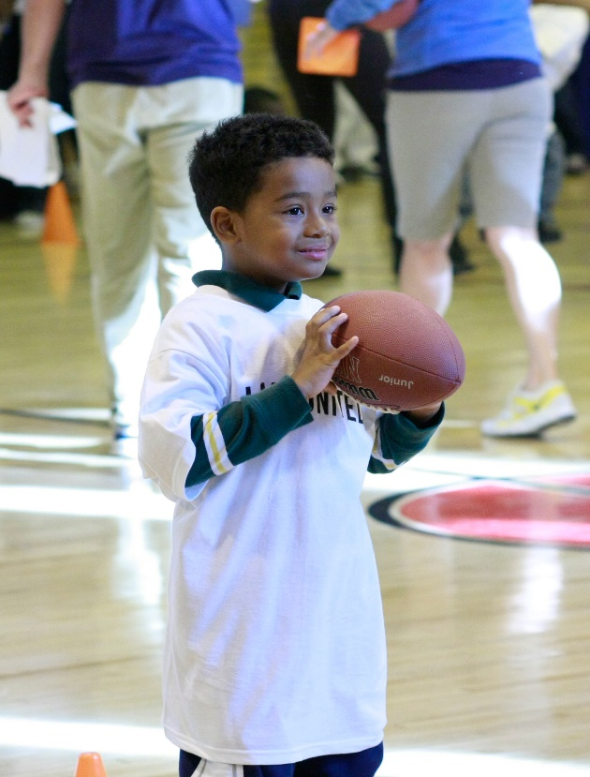
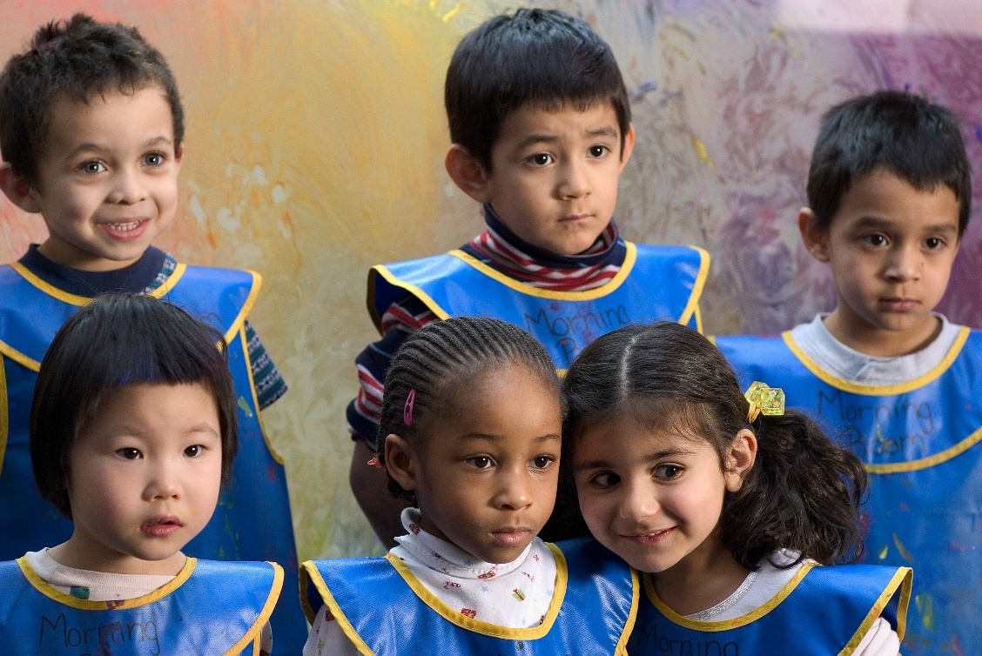
United Way of the Ouachitas
is making an impact on lives and communities.
DID YOU KNOW?

A MESSAGE FROM OUR CAMPAIGN CHAIR
Born and raised here in Hot Springs, Arkansas, I have a deep appreciation for the many organizations whose dedicated work continues to help make our community a better place to live. I am honored to serve as your 2022 Campaign Chair and look forward to working with each and every one of you to address the needs of our community.

I have personally supported United Way of the Ouachitas throughout my adult life, and have always been impressed with their ability to assign every contribution to organizations that make a difference within the Ouachita Region.

My paths have always been bound by a common thread: PEOPLE. Henry Melville said, “We cannot live for ourselves alone. Our lives are CONNECTED by a thousand invisible threads, and along these sympathetic fibers, our actions run as causes and return to us as results.”

Today people find themselves in a state of constant change. The COVID-19 pandemic has amplified our community challenges, creating unprecedented hardships for local families, schools, business and non-profits.

I have seen firsthand that overcoming hardships is about individuals uniting to drive change. It’s about stepping up, adapting, and helping members of our community make way for a better tomorrow. The United Way is a testament to just how significant our impact can be when we come together for a common goal. Join us, and one by one we can rally and be a greater force for positive change.

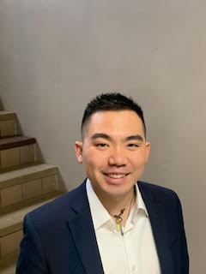
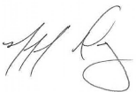
Michael Dang
exp Realty
2022 Campaign Chair

UNITED WAY CAMPAIGN BASICS

What is a Workforce Campaign?

20 – Minute Model
Presentation Package

Opening Remarks
Campaign Coordinator
1 minute

Endorsement
CEO
1 minute

Speaker
United Way Agency
7.5 minutes

Ask for the Gift
Campaign Coordinator
2 minutes

Closing Comments
Thank you and collect
pledge cards
2 minute

TOTAL TIME: 20 minutes
NOTE: Presentation times may be shortened or extended depending on allotted time.
- During a workforce campaign, CEOs and campaign coordinators encourage employees to give to United Way of the Ouachitas.
They motivate people to give by educating them about the
needs in the community and asking them to participate in
company activities.

What’s My Role as a Campaign Coordinator?
- Learn about United Way of the Ouachitas. Please call the
United Way office if you have any questions or need assistance.
- Recruit and coordinate a team of company volunteers to help
you run the campaign.
- Make a personal gift to United Way of the Ouachitas.
- Promote the campaign throughout your organization and ask everyone to give.
- Coordinate the distribution and collection of campaign materials
and pledges.
- Prepare and submit a final report packet and pledge forms.
- Thank ALL campaign participants.

Who Can Help Me Run a Successful Campaign?
- Your Campaign Team Member will be your main United Way
contact during the busy campaign season from August to
December. A Team Member is responsible for personally
contacting and securing corporate contributions and/or
employee contributions from each of their assigned accounts.
- The Resource Development Director is a full-time United Way
of the Ouachitas staff member who is available year-round
to assist with workplace campaigns, call 501.623.2505.

How Do I Achieve Maximum Participation In My Campaign?
- Publicize your efforts in as many ways as possible.
- Make sure to utilize communication methods that our
colleagues use every day – websites, intranets, internal
publications, external publications, media connections,
office mail, e-mails, telephone calls and voicemail messages.

BEST WAY TO ASK CO-WORKERS TO GIVE

Do you know why most people don’t give to United Way?
It’s because they weren’t asked. Not everyone will be able to attend the Campaign Kick-off, so it’s important to follow up with employees. Although it can be difficult to ask your co-workers for money – especially to increase their support – remember that people feel good about helping others. As your colleagues better understand the work of United Way and how their contribution impacts their community, they become more generous.

Quick tips that make asking for a pledge easier:
- Know the facts.
Read the background materials carefully. The more you know about United Way, the easier your job will be. Prepare a solicitation case. Check out United Way’s website at www.unitedwayouachitas.org for facts that make a compelling case for giving.
- Call on co-workers you know first.
Approaching people you know well allows you to be more relaxed and comfortable as you refine your presentation skills. The positive responses you’ll get will boost your confidence.
- Make personal contact.
People give to people. Set up face-to-face meetings to ask for a pledge. It’s best not to just leave pledge forms on someone’s desk.
- Be positive.
Explain the benefits of giving to United Way. Stress the importance of each person’s contribution to our community. Emphasize that you’re asking for funds for urgently needed programs to create long-lasting change that prevents problems from happening in the first place. United Way is working to make our communities a better place to live by focusing on Education, Financial Stability, and Health & Safety.
- Be prepared for questions and concerns.
People deserve to know that their money is being used wisely. Review the responses to the most Frequently Asked Questions regarding United Way (see page 10). If you don’t know the answer to a question, call the United Way office and get back to your colleague.
- Retrieve all pledge cards and say ‘Thank You.’
You should collect a pledge card from each employee – whether or not the individual contributes – as a record that each has been solicited. Remember to thank everyone you contacted. Each person’s time and gift are appreciated and a “thank you” is an important part of your efforts.

TIP FOR SUCCESS
Nothing tells the United Way story better than agency tours because it allows employees to see for themselves how their dollars work to benefit the community. Contact your Campaign Team Member or United Way Resource Development Director to arrange for your group’s agency tours.

10 STEPS TO RUNNING A SUCCESSFUL CAMPAIGN

1. Involve your CEO:
The success of your campaign can be significantly improved based on the commitment and visible involvement of your senior managers and chief executive officer. CEO sample letters are available.

2. Recruit and train your campaign committee:
Your campaign committee will help you manage your organization’s campaign and communicate with employees. Ask your CEO and/or union leadership to help recruit people for all departments and levels of your organization, and from all company sites.

3. Promote leadership giving:
Peer-to-peer solicitation is key to leadership giving. Ask your CEO to appoint an executive to solicit members of the management team for leadership gifts. CEO sample letters are available.

4. Recruit campaign representatives:
Peer outreach and personal follow-up are proven to be the most effective ways to raise funds. Recruit co-workers as campaign representatives to help you answer colleagues’ questions about United Way.

5. Promote and publicize your campaign:
Establishing a financial goal for your campaign is a great way to get people motivated. Your United Way staff contact can provide you materials which get the word out and inform employees about how their contributions can help the community.

6. Hold a kick-off event and employee group meetings:
Build enthusiasm for the campaign by asking your CEO to attend a kick-off event and to publicly endorse the campaign. Add impact to your meeting by contacting your Campaign Team Member or Resource Development Director for presentations and to get a speaker.

7. Have fun with your campaign:
Fun events can create enthusiasm for the campaign. Use ideas in this handbook, a United Way staff contact can provide an idea book for you or go on the website, www.unitedwayouachitas.org.

8. Follow-up with employees and report results:
Midway through the campaign, you should compare last year’s donor list with current contributors to determine who has not yet returned a pledge card. Most people don’t give because they weren’t asked. Collect all triplicate pledge forms whether or not an individual contributes, so you’ll know that everyone has had opportunity to participate.

9. Celebrate success:
Thank everyone who has worked on the campaign. Be sure your Campaign Packet is completed with all the information requested and returned to the United Way office. Thank everyone again. The value of generously thanking everyone involved cannot be overemphasized.

10. Get a jump on planning for next year’s campaign:
Critique the campaign with your CEO, campaign committee and United Way Resource Development Director. Listening to what people liked, what worked and what didn’t will help your organization plan for next year’s campaign.
COMMUNICATING YOUR CAMPAIGN

The most important aspect of your campaign is to get the message out. Plan to talk about or use electronic media to publicize the campaign for a few weeks prior to your campaign kick-off. Repeat the message several times over the course of the campaign. Remember, support from your CEO and department managers is all important. Enlisting and securing their support will send a clear signal to all employees about the importance of participating in the campaign. And most importantly, ask each employee to give.

TECHNOLOGY

E-mail
- Send e-mails to inform employees about specific campaign events and functions. Personalize these communications, if possible.
- Use calendar options to inform employees about the campaign events.
- Send a CEO letter of support by e-mail to all employees. CEO sample letters are available.
- Use e-mail or voicemail to answer employee questions. Quick follow-up is very important.
Company website and intranet
- Create a campaign banner ad to run on your company intranet.
- Post an endorsement letter from your CEO on the company intranet. CEO sample letters are available.
- Include links to United Way’s website, www.unitedwayouachitas.org on your company website so employees can learn about the impact of United Way in your community.
- Post information about campaign events, progress reports, and results on company website and intranet.
Voicemail
- Send voicemail reminders to employees.
- Prepare a special United Way greeting or thank you message.

ESTABLISHED COMMUNICATION METHODS

- Hold campaign kick-off meetings.
- Ensure campaigners contact their assigned employees about the campaign.
- Use payroll stuffers to inform employees about the campaign.
- Display posters.
- Publicize time frames, incentives, contest winners, and campaign results.

ENCOURAGE PAYROLL DEDUCTION!
The easiest way to make an investment in the community is through payroll deduction. Stress to your employees that everyone can afford to give something, be it simply a $1 per week! When everyone participates, it adds up to make a tremendous impact in the community!

EVERYONE LOVES TO WIN!
Allow all donors to receive recognition for pledging to United Way. For example, if pledges are turned in within specified time frames, donors receive special gifts (extra hour for lunch, movie passes, raffle prizes, etc.) You may base your gifts according to what level is pledged or when pledge cards are returned!

WHAT YOUR UNITED WAY DONATION DOES
IS ENOUGH OVER A YEAR’S TIME TO PROVIDE
Provides a free hardback book monthly for 6 children from Imagination Library of the Ouachitas.

52 hours of classes for an emerging artist at Emergent Arts.
Hot meals for five people at The Salvation Army.

30 lunches a day at Eleanor Klugh Jackson House.
50 meals to seniors struggling with food insecurity from Project HOPE Food Bank.

Computer maintenance, programs and upgrades for 10 computers for five classes for 50 individuals for Abilities Unlimited.

Support a young person, kindergarten through 12th grade to attend after school care at High Impact Movement where they receive a snack, academic tutoring, and enrichment activities.
GIVING THIS MUCH
$10 per week/$520 per year
or the cost of a deli sandwich

$20 per week/$1040 per year
or the cost of one lunch out

$30 per week/$1560 per year
or the cost of one shirt

$40 per week/$2080 per year
or the cost of one dinner out

$50 per month/$600 per year or the cost of a gym membership
Giving to United Way of the Ouachitas is an easy way to benefit United Way’s Community Partner Agencies and Community Impact Actions, such as We’ve Got Talent, Day of Caring, and Stuff the Bus. Donors can designate their contribution to a specific Community Partner Agency, Impact Action, or to one of the three Impact Areas, Education, Financial Stability, and Health & Safety. Regardless of whether or not a gift is designated to a specific program or impact area, donors can rest assured that their dollars are tackling the issues that matter most to the communities United Way serves.

TIP FOR SUCCESS
Use examples from this chart to demonstrate to employees the positive impact that their dollars can have on our area.

CAMPAIGN AWARDS, PLEDGE CARDS, AND IDEAS
LOYALTY DONOR
United Way’s Loyalty Donor Program is designed to recognize long-time donors to United Way, regardless of the amount. They not only show their belief in our mission but become the backbone upon which United Way exists. There is a place on the pledge card to indicate how many years a donor has contributed to United Way. Please encourage your colleagues who you know are Loyalty Donors to indicate it on the pledge card, so United Way may recognize and thank them.

Campaign Awards
United Way of the Ouachitas recognizes organizations and businesses annually for their commitment and service. These awards will be distributed at the annual wrap-up celebration.

Triplicate Pledge Cards
Your United Way pledge card is in compliance with IRS regulations. It is a three-part document (9 ¼ x 5 ½ inches) so donors will have a copy to use for tax deductions. In addition to the pledge card, a campaign card containing information about United Way is available.

Here are the guidelines from the IRS:
When a donor makes a contribution by payroll deduction, the donor must have the following documents to substantiate the deduction:
- A pay stub, W-2 or other document furnished by the employer that indicates the amount withheld during the tax year for payment to the doner organization and,
- A pledge card, or other document prepared by the doner organization that shows the doner organization’s name
If you have additional questions about the pledge card, please contact Sarah Fowler at 501.623.2505.

START A YEAR-ROUND PROGRAM
Campaigning for pledges will be much easier when your employees are exposed to United Way and its agencies year-round.
- New hires program – When new employees are hired, give them the opportunity right away to give through payroll deduction. Don’t wait until campaign time.
- Agency tours – Don’t wait unit campaign time to have employees tour a United Way Community Partner. Nothing tells the United Way of the Ouachitas story better than tours because it allows employees to see for themselves how their dollars work to benefit the community. Just give the United Way office a call and tours will be arranged, and you don’t even have to send a large group.
- Year-round fundraising – Many companies are planning activities to coincide with special occasions or holidays, such as; silent auction of baskets for holiday giving, lunches, golf tournaments, and raffles.
- Use newsletter updates – Keep employees informed and involved through internal communication tools like bulletin board displays or special messages on your company’s intranet.
- Browse the website – You can visit our website, www.unitedwayouachitas.org for more information.
FAQ’S ABOUT UNITED WAY OF THE OUACHITAS
Why should I invest in United Way of the Ouachitas?
A. United Way of the Ouachitas is committed to making the kinds of smart choices which can make our community a better place for all of us to live and work. We use our expertise and community connections to support thousands of people throughout our region in ways that make a genuine difference in their lives. We use our time and resources as efficiently as we can, to do as much as we can and to help as many people in as many ways as we can.

Why am I asked to give to United Way in my workplace?
A. United Way of the Ouachitas has always enjoyed a strong partnership with the business community. Organizations which host a workplace campaign understand that we all share a responsibility for the people and neighborhoods where we live, work and raise our families. Employees in our annual workplace campaign donate 50% to our campaign and inspire many volunteer hours which contribute to real and lasting progress throughout the community.

Why should I give to United Way in addition to my other charities?
A. Everyone should give to the charities which are closest to their hearts. However, a gift to United Way will extend charitable giving by investing in the needs which United Way of the Ouachitas serves.

Why should I give to United Way instead of a direct service agency?
A. Again, we encourage people to give to all their charities including direct service agencies. However, United Way of the Ouachitas bases its funding allocations on a rigorous process demanding accountability from its partners. We employ our resources and expertise to work closely with our partners so together we will achieve real and lasting impact in the communities we serve.

Who decides how much money goes to each program or service?
A. People just like you! Trained volunteers work on year-round committees called Community Impact Teams to study our most serious problems and the best way to remedy them. Those volunteer groups decide where to allocate the funds, assess community needs through an extensive process and they then direct resources – money and volunteers – to the area where there are existing or emerging needs. United Way’s Board of Directors makes final funding decisions.

What does United Way do with my donation?
A. Annual campaign contributions are distributed each year through a vigorous allocation process. United Way’s mission is to improve lives by connecting people and resources in our area. We’re focused on critical issues like Education, Income Stability, and Health & Safety especially as they impact childhood poverty.

Does United Way of the Ouachitas support abortion or fund Planned Parenthood?
A. No. United Way of the Ouachitas does not fund programs that deliver abortion services nor has it in the past, nor is there a Planned Parenthood Agency in our region. Planned Parenthood is not a member agency, so it receives no allocations or undesignated contributions.

How does an organization apply to receive funding from United Way of the Ouachitas?
A. When resources allow, United Way invites applications from organizations that demonstrate measurable results in addressing key issues our communities have identified as most important. United Way also helps to meet basic needs, such as food and shelter.

SOURCE OF CONTRIBUTIONS AND PLEDGES
TO THE 2021 UNITED WAY CAMPAIGN

United Way and its Community Partner Agencies are dependent on the generous donors who contribute to the campaign each year. Employee giving plays a key role in the campaign’s success. It accounts for over 50% of all contributions made to the United Way of the Ouachitas Campaign each year. Employee giving contributions come in the form of payroll deductions, direct bills and one time gifts.
Corporate and Foundation giving is also vital to United Way and its annual campaign. Many companies participate in matching programs which are based upon overall employee giving totals. Such matchers vary from $.15 per $1.00 donated to $1.00 for $1.00. Match programs often help increase employee totals by providing an extra incentive for employees to participate.
Special events hosted by companies and organizations also play an important role in raising dollars for United Way. Often times, special events will engage individuals who otherwise do not participate in the annual campaign. United Way will also help in advertising your special event by featuring it on our Facebook page, website and other communications.
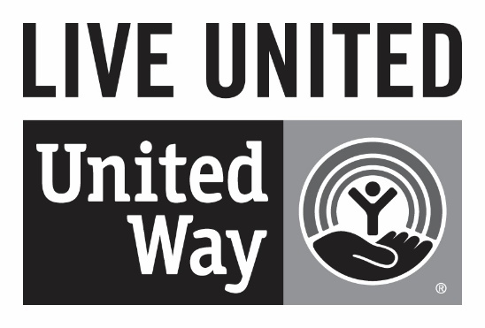
2022 United Way Board of Directors

Executive Committee
President
Lisa Austin,
Bank OZK

First Vice President
Michael Dang,
exp Realty

Treasurer
Ronnie Backus,
Arvest Wealth Management

Secretary
Pam Perry,
First Security Bank

At Large
Jennifer Bearden,
US Bank
Paul Nothern,
Retired
Aaron Street,
City of Hot Springs

Immediate Past President
Brandon Scott,
BScott Creative

Members:
Shanara Armstrong,
Lily Pad Preschool Academy

Jennifer Bailey,
KLAZ Morning Show Cohost

Chief Chris Chapmond,
Hot Springs Police Dept.

Logan Gaither-Fisk,
Area Agency on Aging

Spencer Gaither-Fisk,
Bank OZK

Miranda Johnson,
Relyance Bank

Mara Kuhn,
Greater Hot Springs
Chamber of Commerce

Catherine Monroe,
Regions Bank

Dr. Stephanie Nehus,
Hot Springs School District

Stuart Shenep,
Simmons Bank

Campaign Chair
Michael Dang,
exp Realty
We’re here to help you!
If at any time you have questions, please call Sarah Fowler at 501.623.2505 or
E-mail at sarah.fowler@unitedway.org.

Be sure and visit the United Way website, www.unitedwayouachitas.org for updated event information, as well as ideas and suggestions for your organization’s campaign.

YOUR UNITED WAY DONATION GOES FAR; JUST NOT FAR AWAY
United Way of the Ouachitas
233 Hobson Avenue
Hot Springs, AR 71913
Phone: 501.623.2505
Web: www.unitedwayouachitas.org
United Way of the Ouachitas Staff
Sarah Fowler
Executive Director
Mandy Spraggins
Marketing Director
Karen Vance
Finance Director
Pat Long
Chief Volunteer

